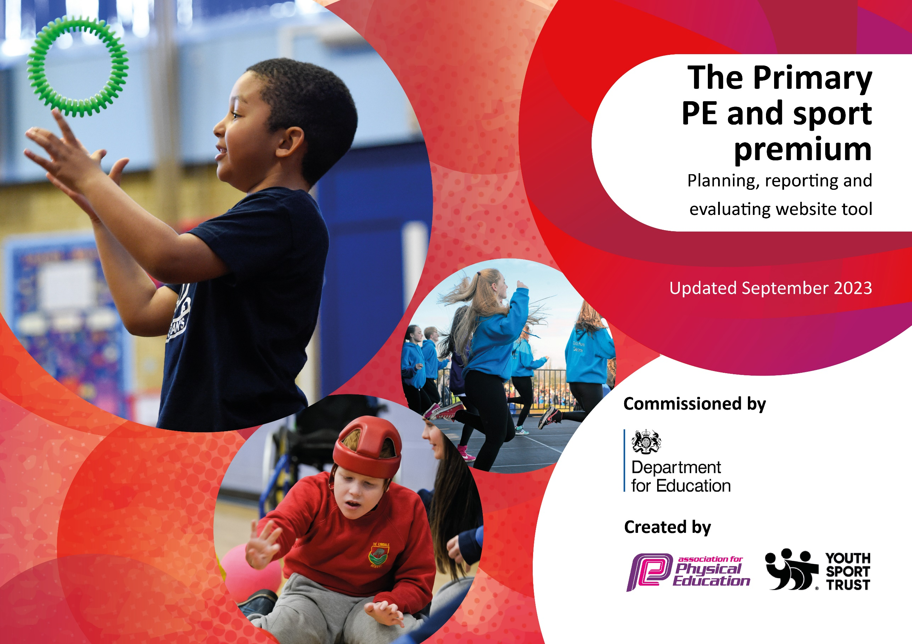

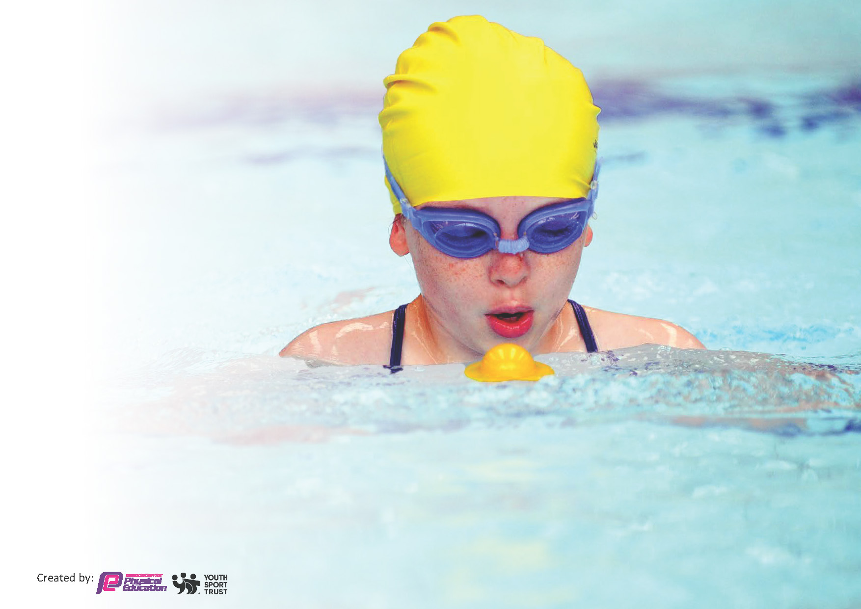
This template can be used for multiple purposes:
by:
- It enables schools to effectively plan their use of the Primary PE and sport premium
- It helps schools to meet the requirements (as set out in guidance) to publish information on their Primary PE and sport premium
- It will be an effective document to support Ofsted inspections enabling schools to evidence progress in Physical Education (PE) and evidence swimming attainment, which forms part of the PE National Curriculum. We would recommend schools consider
the Intent, Implementation and Impact of any spend, as examined within the Education Inspection Framework.

It is important that your grant is used effectively and based on school need.

Schools must use the funding to make additional and sustainable
improvements to the quality of the PE, School Sport and Physical Activity (PESSPA)
they offer. This means that you should use the Primary PE and sport premium to:

- Build capacity and capability within the school to ensure that improvements made now will benefit pupils joining the school in future years
- Develop or add to the PESSPA activities that your school already offers.

The Primary PE and sport premium should not be used to fund capital spend projects; the school’s core budget should fund these. Further detail on capital expenditure can be found in the updated Primary PE and sport premium guidance.

The Primary PE and sport premium guidance, outlines 5 key priorities that funding should be used towards. It is not

necessary that spending has to meet all the key priorities, you should select the priorities that you aim to use any funding towards.

Although completing this template is not a requirement for schools, schools are required to publish details of how they spend this funding. Schools must also outline what the impact this funding has had on pupils’ PE and sport participation and attainment and how any spending will be sustainable in the future. All funding must be spent by 31st July 2024.

The Department for Education has worked closely with the Association for Physical Education (afPE) and the Youth Sport Trust (YST) to develop this template and encourages schools to use it. This template is an effective way of meeting the reporting requirements of the Primary PE and sport premium.
Review of last year’s spend and key achievements (2023/2024)

We recommend you start by reflecting on the impact of current provision and reviewing your previous spend.

Activity/Action | Impact | Comments
Geocaching and Archery  Freestyle Football  Ice skating | Children in all years tried a new sport and were able to work on team building skills  Through workshops, children were engaged in a “practice makes permanent” mindset  Children were able to try a new sport that created resilience and cooperative learning  All of the above were inclusive and supports and scaffolds were put in place to ensure all children were able to take part

Key achievements 2023-2024
Action – | Who did this action impact? | Key indicator to met | Impacts and how sustainability will be achieved? | Cost linked to the action
Purchased equipment for astro surface and for the two playgrounds | Lunchtime supervisors / teaching staff, coaches - as they need to lead the activity  pupils – as they will take part. | Key indicator 1 -The engagement of all pupils in regular physical activity  Key indicator 4: Broader experience of a range of sports and activities offered to all pupils. | More pupils meeting their daily physical activity goal, more pupils encouraged to take part in PE and Sport Activities. | £600 costs for resources
Supported participation in sport through employment of sports coaches for after school clubs | Pupils – as they will take part | Key indicator 1 -The engagement of all pupils in regular physical activity | From September 2024, children will be offered a wide range of after school activities  School will be more able to engage with competitive sports.

Introduce a varied and enriched offer of sports and activities during the year | Pupils gain access to wider range of sports | Key indicator 4: Broader experience of a range of sports and activities offered to all pupils.  Key indicator 2 - The profile of PE and sport is raised across the school as a tool for whole-school improvement | More pupils exposed to the mental wellbeing that sport can provide and promote | £5000 for outside agencies to provide enrichment
Provide two hours weekly of quality PE provision and coaching during curriculum time | Pupils take part  Staff – access to CPD through qualified coach | Key indicator 1 -The engagement of all pupils in regular physical activity  Key indicator 3 - Increased confidence, knowledge and skills of all staff in teaching PE and sport | More pupils meet the goal of two hours quality PE during a week | £592 – Get Set registration  £1,000 – School Sports Association
Provide a competitive outlet for school sports | Pupils take part in activity  Parents engage with school sports | Key Indicator 5 - Create opportunity for competition and, in turn, inspire teamwork, perseverance, empathy and tenacity. | See KI 5 | £400
Bikeability offer | Pupils | Key indicator 1 -The engagement of all pupils in regular physical activity |  | £500
Provide annual Forest School experience | Pupils take part | Key indicator 1 -The engagement of all pupils in regular physical activity  Key indicator 3 - Increased confidence, knowledge and skills of all staff in teaching PE and sport |  | £7,525 – contract for full year
Playpod Scrapstore | Pupils take part in physical and collaborative play | Key indicator 1 -The engagement of all pupils in regular physical activity  Key Indicator 5 - Create opportunity for competition and, in turn, inspire teamwork, perseverance, empathy and tenacity. |  | £500
Provide daily movement session – Dellar’s Disco – to encourage regular attendance and to regulate behaviour prior to lessons starting | Pupils (PA) take part  Teachers can have a regulated start to the day  Parents are supported getting children with low attendance into school | Key indicator 1 -The engagement of all pupils in regular physical activity  Key indicator 2 - The profile of PE and sport is raised across the school as a tool for whole-school improvement

This template will be completed at the end of the academic year and will showcase the key achievements schools have made with their Primary PE and sport premium spending.

Activity/Action | Impact | Comments

Swimming Data
Meeting National Curriculum requirements for swimming and water safety.
Priority should always be given to ensuring that pupils can perform safe self-rescue even if they do not fully meet the first two requirements of the National Curriculum programme of study

Question | Stats: | Further context  Relative to local challenges
What percentage of your current Year 6 cohort can swim competently, confidently and proficiently over a distance of at least 25 metres? | 83%
What percentage of your current Year 6 cohort can use a range of strokes effectively [for example, front crawl, backstroke, and breaststroke]? | 32%

What percentage of your current Year 6 cohort are able to perform safe self-rescue in different water-based situations? | 34%
If your schools swimming data is below national expectation, you can choose to use the Primary PE and sport premium to provide additional top-up sessions for those pupils that did not meet National Curriculum  requirements after the completion of core lessons. Have you done this? | Yes/No
Have you provided CPD to improve the knowledge and confidence of staff to be able to teach swimming and water safety? | Yes/No | Two staff have received shallow water training to support swimmers in the water.

Signed off by:

Head Teacher: | Lisa Tweed
Subject Leader or the individual responsible for the Primary PE and sport premium: | Adam Dellar/Martin James
Governor: | Alistair Paterson
Date: | 11.7.24

